Econ 206/Test 1 Write your name on your scantron (-2 if not)

n
1. In the expression ∑ (X_{i})²,
_{i=1}

a. n refers to the total number of observations in your data set
b. i refers to the last observation in your data set
c. X refers to the average of the data set
d. none of the above
n
2. If given the expression ∑ (X_{i} – 2)², and the data set 0, 2, 4, the expression simplifies to
_{i=1}
a. 0 b. 2
c. 4 d. none of the above
3. Pie charts are most useful for
a. quantitative data b. time series data
c. qualitative data c. longitudinal data
4. Which of the following can have a substantial impact on the appearance of a histogram?
a. width of the data intervals b. number of qualitative categories
c. time unit of observations d. none of the above
5. Which formula is correct for computing the change in monthly S&P 500 values?
a. current month – prior month
b. (current month – prior month)*100
c. (prior month/current month)*100
d. 100*(current month – prior month)/prior month)
6. The percentage change in the weekly number of flu cases reported by the CDC equals
current month – prior month
a. (current month – prior month)*100
b. (prior month/current month)*100
c. 100*(current month)/prior month)
d. none of the above
7. Data are sometimes converted to logarithms for statistical analysis so that
a. decimal places will be reduced
b. negative values will be removed
c. the data will have more of a bell shape
d. all of the above
8. In many statistical studies of national or cross-national data, the data are converted to “per capita” values. This means that the original variable
a. is converted into logarithms b. is divided by population
c. is divided by income d. none of the above
9. Suppose that we use a scale to measure weight of individuals in the classroom. On average,
scale it is records a value that is too high relative to the true weight of each person but it is
always gives the same value for the same person in repeated measures. This is an example of
a. a reliable measure b. valid measure
c. a binary measure d. all of the above

date | open | high | low | close | volume | change
2-Jan-01 | 1320.28 | 1320.28 | 1276.05 | 1283.27 | 11294
3-Jan-01 | 1283.27 | 1347.76 | 1274.62 | 1347.56 | 18807 | 64.29004
4-Jan-01 | 1347.56 | 1350.24 | 1329.14 | 1333.34 | 21310 | -14.2201
5-Jan-01 | 1333.34 | 1334.77 | 1294.95 | 1298.35 | 14308 | -34.99
8-Jan-01 | 1298.35 | 1298.35 | 1276.29 | 1295.86 | 11155 | -2.48999
9-Jan-01 | 1295.86 | 1311.72 | 1295.14 | 1300.8 | 11913 | 4.940063
10-Jan-01 | 1300.8 | 1313.76 | 1287.28 | 1313.27 | 12965 | 12.46997

10. The data in the table above for S&P 500 values is of which type?
a. qualitative data b. time series data
c. longitudinal data d. none of the above
11. The Major League Baseball data listing teams, winning percentage, and other variables for each MLB team from 1970-2011 is of which type?
a. cross-sectional b. reliable
c. longitudinal data d. none of the above
12. Suppose that we collected data on food expenses for 1000 selected households each year for 10 years. This is an example of
a. qualitative data b. cross-sectional data
c. experimental data d. longitudinal data
13. When the term, X_{i}, appears in statistical analysis,
a. the “i” refers to a particular observation such as the first, second, third ...
b. the “X” refers to a measurement that can take on only one value
c. the X_{i} refers to the sum of all of the values for the given variable
d. none of the above
14. Suppose that “intelligence” is the construct and that IQ is the operational measure of it. In the graphic displayed, the center of the bulls-eye indicates an accurate measure of intelligence and the dots represent repeated measures of IQ. Which panel represents a valid measure that is the most reliable?

15. Time plots of data are useful for
a. distinguishing highs and lows that occur seasonally
b. distinguishing trends in the data
c. distinguishing the cyclical patterns in the data
d. all of the above

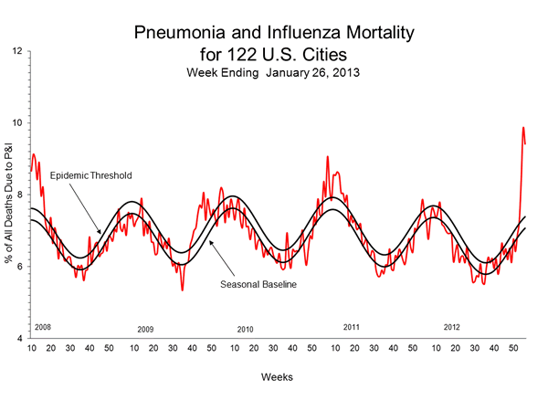
16. The data displayed above is
a. a histogram b. a time series plot
c. a scatterplot d. none of the above
17. The GapMinder World graphic showing life expectancy and GDP per capita across countries is an example of a
a. multi-dimensional graphic b. histogram
c. time series plot d. none of the above
18. Which of the following is a widely used statistical software among companies and governments?
a. SAS b. SAA
c. SSA d. none of the above
19. Which of the following is a movie that depicts the impact data analytic (statistical) revolution over the past 15 years as part of its main story line?
a. Blow b. Casino Royale
c. Moneyball d. none of the above
20. Suppose that 500 crimes were committed in a city of 100,000 people. The crime rate per 1,000 people would be
a. 0.005 b. 0.05
c. 0.500 d. 5.00
21. Put “A” for your answer

Correct Answers:
1a, 2d, 3c, 5a, 6a, 6d, 7c, 8b, 9a, 10b, 11c, 12d, 13a, 14a, 15d, 16b, 17a, 18a, 19c, 20d

